ARYAMAN MISHRA

19BCE1027

1.SCENERY

#include<stdio.h>

#include<conio.h>

#include<graphics.h>

#include<math.h>

#include<dos.h>

void main()

{

int gdriver=DETECT,gmode;

initgraph(&gdriver,&gmode,"C:\\TURBOC3\\BGI");

line(150,50,200,100);

line(150,50,80,120);

line(80,120,100,120);

line(150,50,350,50);

line(350,50,400,100);

line(100,100,100,200);

line(100,200,200,200);

line(200,100,200,200);

line(400,200,400,100);

line(200,200,400,200);

line(200,100,400,100);

rectangle(130,130,170,170);

rectangle(250,130,320,200);

line(320,130,305,140);

line(305,140,305,140);

line(250,130,265,140);

line(265,140,265,200);

line(100,200,90,210);

line(90,210,200,200);

line(190,210,200,200);

line(190,210,410,210);

line(400,200,410,200);

//HOUSE COLOR

setfillstyle(8,2);

floodfill(131,131,WHITE);

setfillstyle(11,7);

floodfill(101,101,WHITE);

setfillstyle(1,12);

floodfill(163,55,WHITE);

setfillstyle(1,12);

floodfill(82,119,WHITE);

setfillstyle(3,10);

floodfill(251,121,WHITE);

setfillstyle(1,6);

floodfill(150,205,WHITE);

setfillstyle(1,6);

floodfill(250,205,WHITE);

setfillstyle(5,12);

floodfill(310,145,WHITE);

setfillstyle(5,12);

floodfill(260,145,WHITE);

//tree

line(505,130,505,200);

line(532,130,532,200);

line(505,200,531,200);

line(480,130,560,130);

line(480,130,500,100);

line(500,100,480,100);

line(480,100,500,70);

line(500,70,480,70);

line(480,70,520,40);

line(560,130,540,100);

line(540,100,560,100);

line(560,100,540,70);

line(540,70,560,70);

line(560,70,520,40);

//color tree

setfillstyle(1,6);

floodfill(506,131,WHITE);

setfillstyle(1,2);

floodfill(510,101,WHITE);

//ROAD

line(270,210,290,390);

line(315,210,360,390);

line(0,390,290,390);

line(360,390,639,410);

line(0,410,639,410);

line(0,390,0,410);

line(639,390,639,410);

setfillstyle(1,6);

floodfill(1,391,WHITE);

//MOUNTAIN

line(100,180,0,180);

line(400,180,505,180);

line(532,180,639,180);

line(100,150,50,110);

line(50,110,0,150);

line(400,150,450,110);

line(450,110,505,150);

line(532,150,590,110);

line(590,110,639,150);

setfillstyle(1,8);

floodfill(50,50,WHITE);

setfillstyle(1,8);

floodfill(401,150,WHITE);

setfillstyle(1,8);

floodfill(535,150,WHITE);

setfillstyle(1,9);

//SKY

floodfill(0,0,WHITE);

setfillstyle(1,9);

floodfill(504,148,WHITE);

setfillstyle(1,9);

floodfill(535,132,WHITE);

//SUN

circle(70,50,40);

setfillstyle(1,14);

floodfill(71,51,WHITE);

//POND

ellipse(550,300,0,360,80,50);

setfillstyle(1,3);

floodfill(550,330,WHITE);

//GRASS COLOR

setfillstyle(1,2);

floodfill(20,50,WHITE);

setfillstyle(1,2);

floodfill(350,230,WHITE);

getch();

}

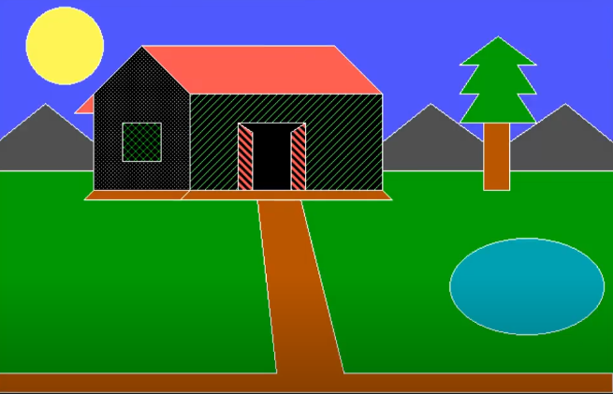

2.FLAG

#include<stdio.h>

#include<graphics.h>

#include<math.h>

#include<conio.h>

int main()

{

int gd,gm;

int r,i,a,b,x,y;

float PI=3.14;

detectgraph(&gd,&gm);

initgraph(&gd,&gm,"C:\\TURBOC3\\BGI");

setcolor(RED);

rectangle(100,100,450,150);

setfillstyle(SOLID_FILL,RED);

floodfill(101,101,RED);

setcolor(WHITE);

rectangle(100,150,450,200);

setfillstyle(SOLID_FILL,WHITE);

floodfill(101,151,WHITE);

setcolor(GREEN);

rectangle(100,200,450,250);

setfillstyle(SOLID_FILL,GREEN);

floodfill(101,201,GREEN);

a=275;

b=175;

r=25;

setcolor(BLUE);

circle(a,b,r);

//spokes

for(i=0;i<=360;i=i+15)

{

x=r*cos(i*PI/180);

y=r*sin(i*PI/180);

line(a,b,a+x,b-y);

}

getch();

closegraph();

return 0;

}



3.OBJECT(ROCKET)

#include<stdio.h>

#include<conio.h>

#include<graphics.h>

#include<maths.h>

#include<dos.h>

void main()

{

int gd=DETECT,gm=0;

initgraph(&gd,&gm,"C:\\TURBOC3\\BGI");

line(250,250,250,400);

line(320,250,320,400);

ellipse(285,260,0,360,35,10);

ellipse(285,400,0,360,35,10);

setfillstyle(SOLID_FILL,12);

fillellipse(285,260,35,10);

fillellipse(285,400,35,10);

setcolor(6);

setcolor(WHITE);

line(250,250,250,200);

line(320,250,320,200);

line(250,200,285,150);

line(320,200,285,150);

line(250,200,320,200);

line(260,200,285,165);

line(310,200,285,165);

line(270,200,285,175);

line(300,200,285,175);

line(280,200,285,185);

line(290,200,285,185);

line(260,200,260,252);

line(270,200,270,251);

line(280,200,280,250);

line(290,200,290,250);

line(300,200,300,251);

line(310,200,310,252);

line(250,400,220,450);

line(320,400,350,450);

line(220,450,350,450);

setfillstyle(SOLID_FILL,4);

getch();

closegraph();

}

